ASSIGNMENT 1

QN1

**Wap to demonstrate ternary operator .define a variable marks  .ask its value from user and using ternary operator check if marks > 40 store "Pass" in result varible else store "Fail**"

Code And Output-

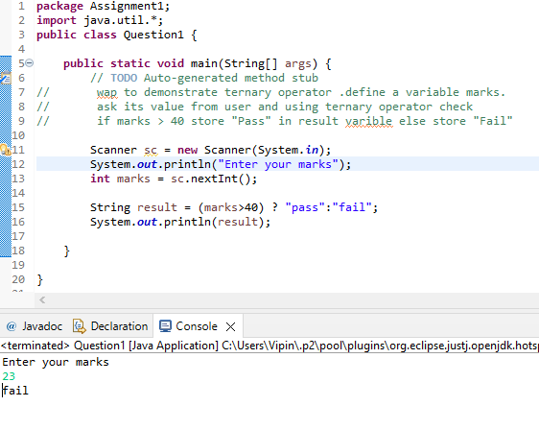

QN2

**using ternary check if number entered by user is positive or negative .  
In case number is positive store "Positive number" else store negative number to Result variable**

Code And Output

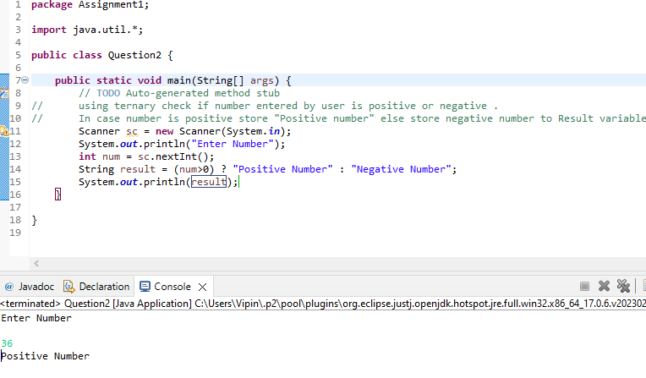

**QN3**

**WAP to ask name ,age and salary of an employee and print on console**.

Code And Output

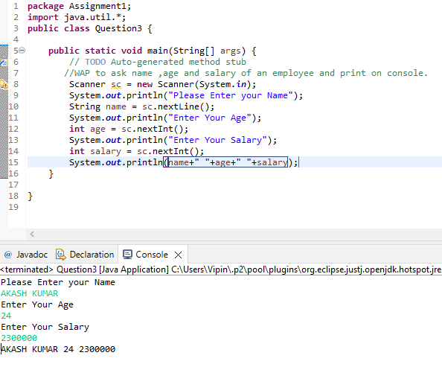

QN4

**Wap  that ask two numbers from user and print greater number among two .**

**Code And Output**

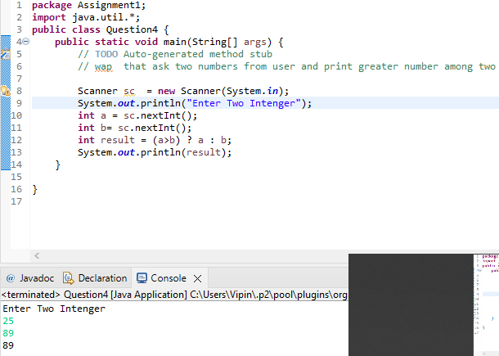

QN5

**wap to ask product name and price of product from user and calculate discount i.e   
if price > 2000 then discount is 10 percent of price   
else   
discount is 7 % of price**

Code And Output

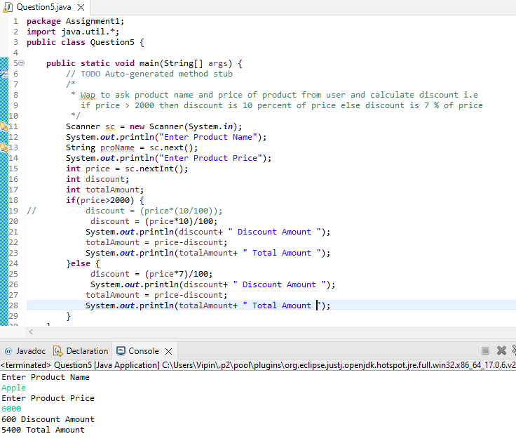

QN6

**Wap to swap two numbers**

**Code And Output**

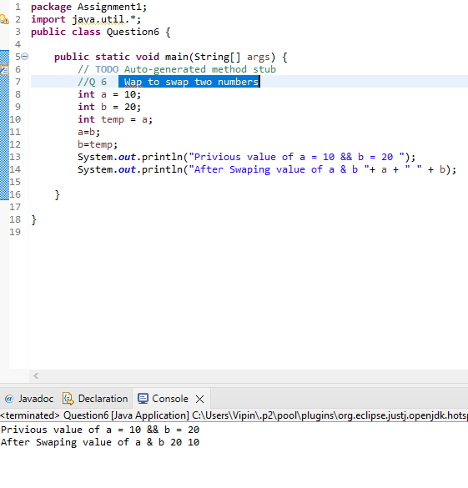

QN8

**Wap to check is number is even or odd.**

**Code And Output**

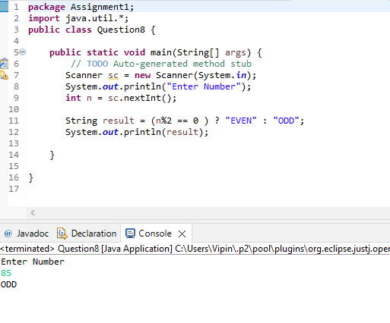

QN9

**A school has following rules for grading system:  
 a. Below 25 - F  
 b. 25 to 45 - E  
 c. 45 to 50 - D  
 d. 50 to 60 - C  
 e. 60 to 80 - B  
 f. Above 80 - A  
 Ask user to enter marks and print the corresponding grade**

**Code And Output**

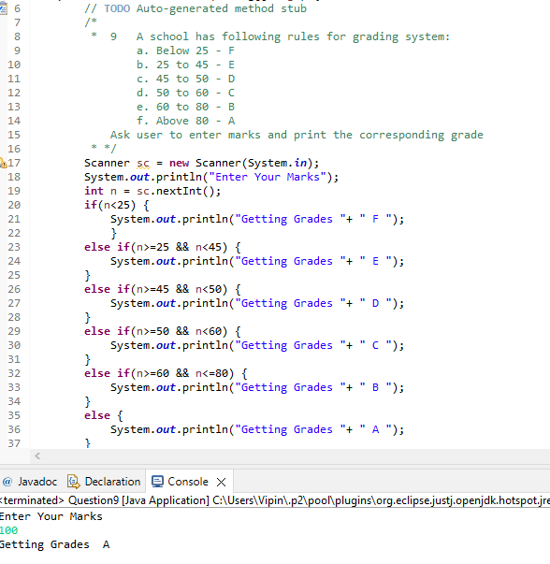

QN10

**Wap to check greater number among three numbers**

**Code And Output**

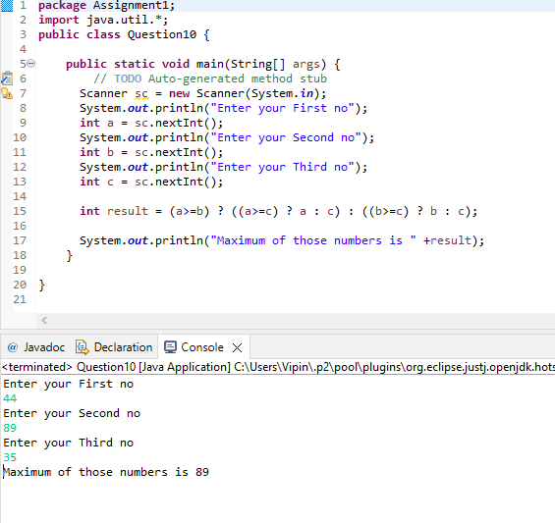

QN7

**How to swap two numbers without using a third variable?**

**Code And Output**

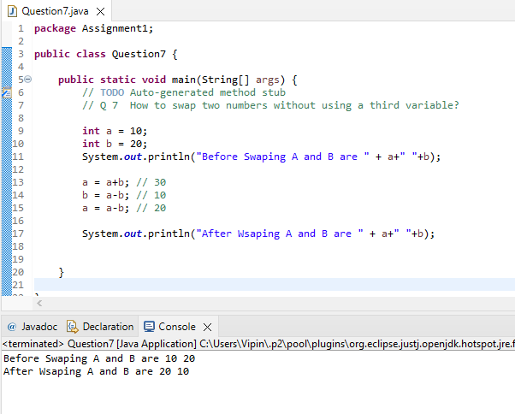

**SUBMITTED BY :-**

**Mithlendu Kumar**